

Master of Computer Applications
Semester – III
Data Analytics for Business
Experiment No.: 8
Title: End-to-End Business Analytics Capstone Project

Submitted By:
Name: A.Deepak
Reg. No.:2511022250001
Date:23/08/2026

Submitted To:
Faculty Name: Mr. Aman Kumar Sharma

Department of Computer Application
Alliance University
Chandapura - Anekal Main Road, Anekal
Bengaluru – 562106

Experiment No.: 8
End-to-End Business Analytics Capstone Project

Problem Statement
You are a Business Intelligence Consultant for a growing organization. Your task is to develop an end-to-end Business Analytics solution using a dataset of your choice to support data-driven business decisions.

Methodology / Steps Followed
- Dataset Collection – Collected the HR Analytics dataset containing employee demographics, job details, salary, satisfaction, performance, overtime, and attrition information.
- Data Storage in MySQL – Imported the dataset into MySQL Workbench and created the hr_analysis database.
- Data Cleaning & Preparation – Checked missing values, data types, duplicate records, and inconsistent column values using MySQL and Power Query.
- SQL Data Preparation – Used SQL queries to inspect, filter, and prepare employee data for analysis.
- Data Modeling – Created Fact and Dimension tables and established relationships using a Star Schema in Power BI.
- Power Query Transformation – Performed data type conversion, column transformations, and creation of analytical categories such as Age Group and Income Band.
- DAX Measures & KPIs – Created measures such as Total Employees, Employees Left, Attrition Rate, Average Monthly Income, Job Satisfaction, and Overtime Employees.
- Dashboard Development – Developed interactive Power BI dashboards with KPI cards, charts, slicers, and a Reset Filters button.
- Business Analysis – Analyzed attrition based on department, job role, income, satisfaction, overtime, work-life balance, performance, travel, distance, and tenure.
- Insights & Recommendations – Identified key employee-retention patterns and provided actionable recommendations for improving workforce retention.
- Power BI Service Deployment – Published the completed report to Power BI Service and configured an On-premises Data Gateway for MySQL connectivity.

Output:
Importing Dataset into MySQL database:
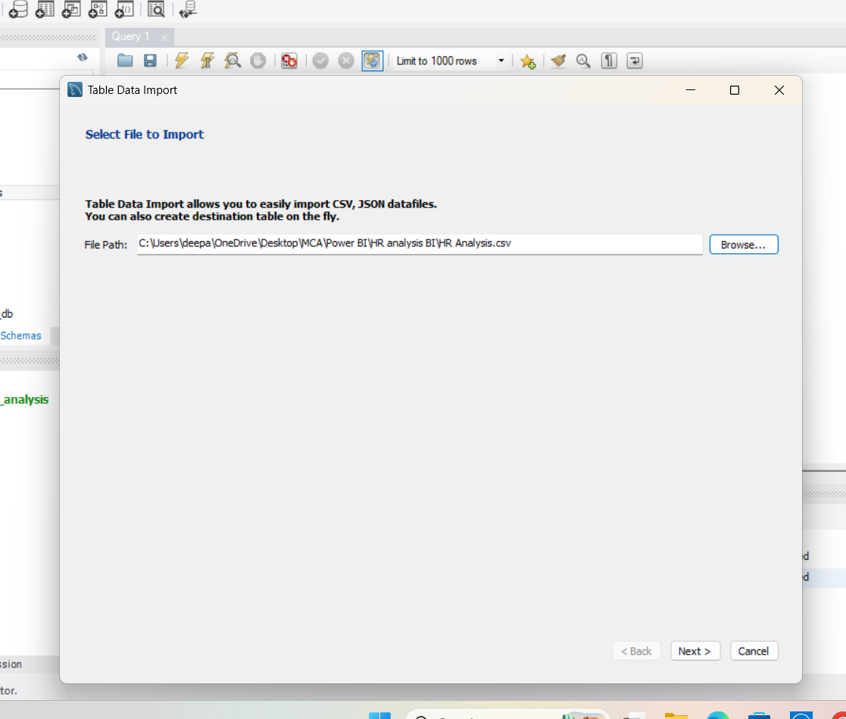
Creating Table:
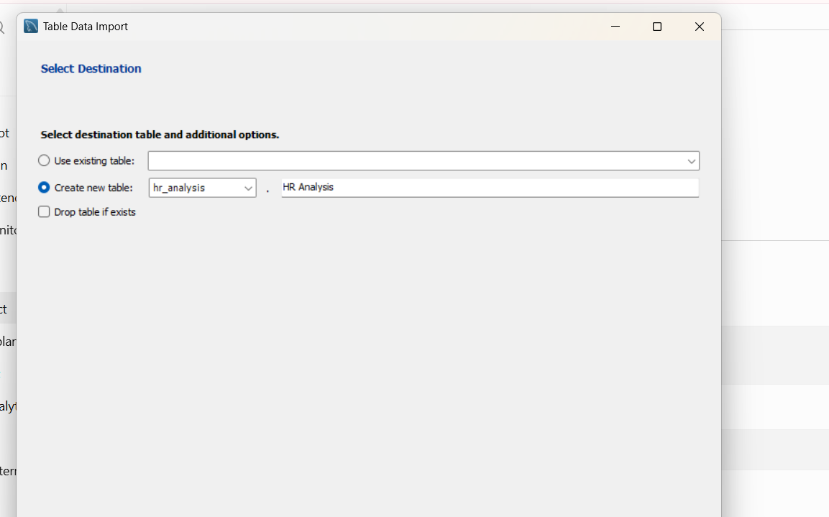
Imported Dataset:
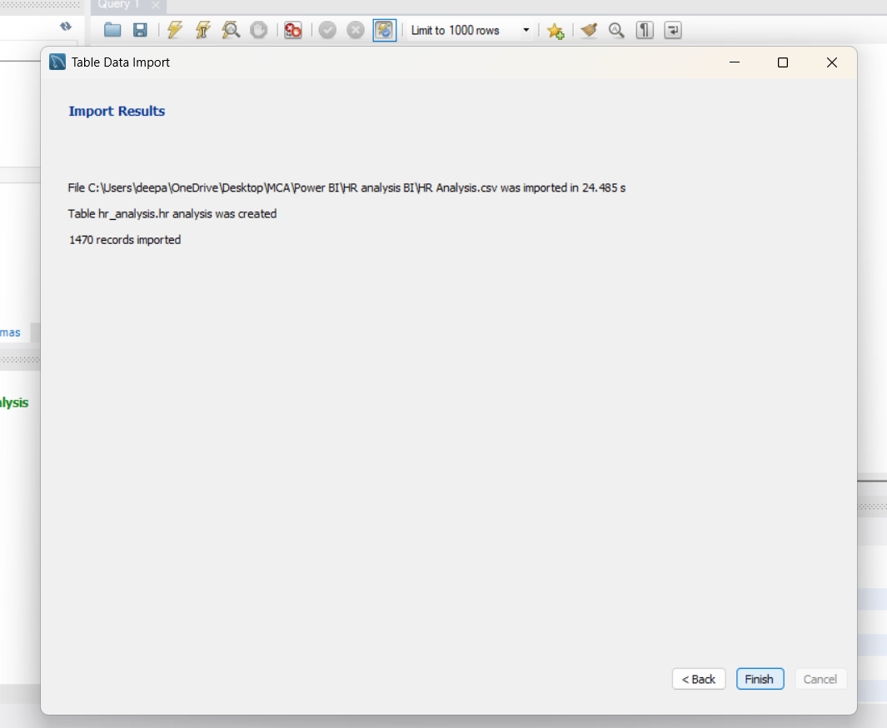
Created Fact & Dimensions tables:
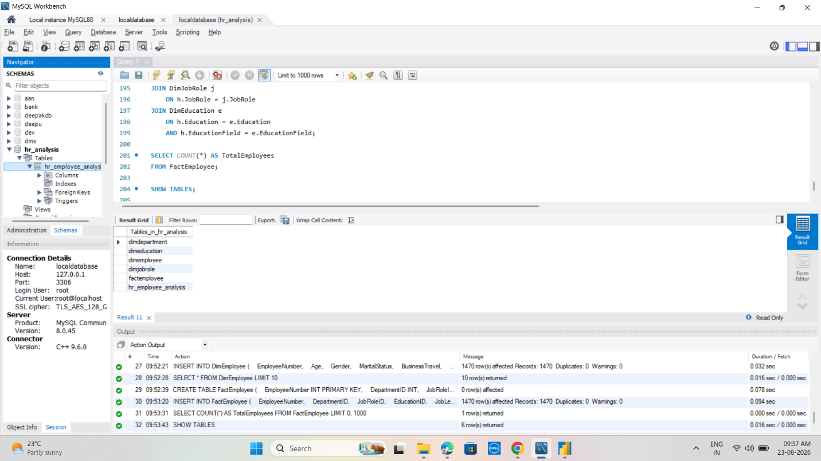

Model Relationships:
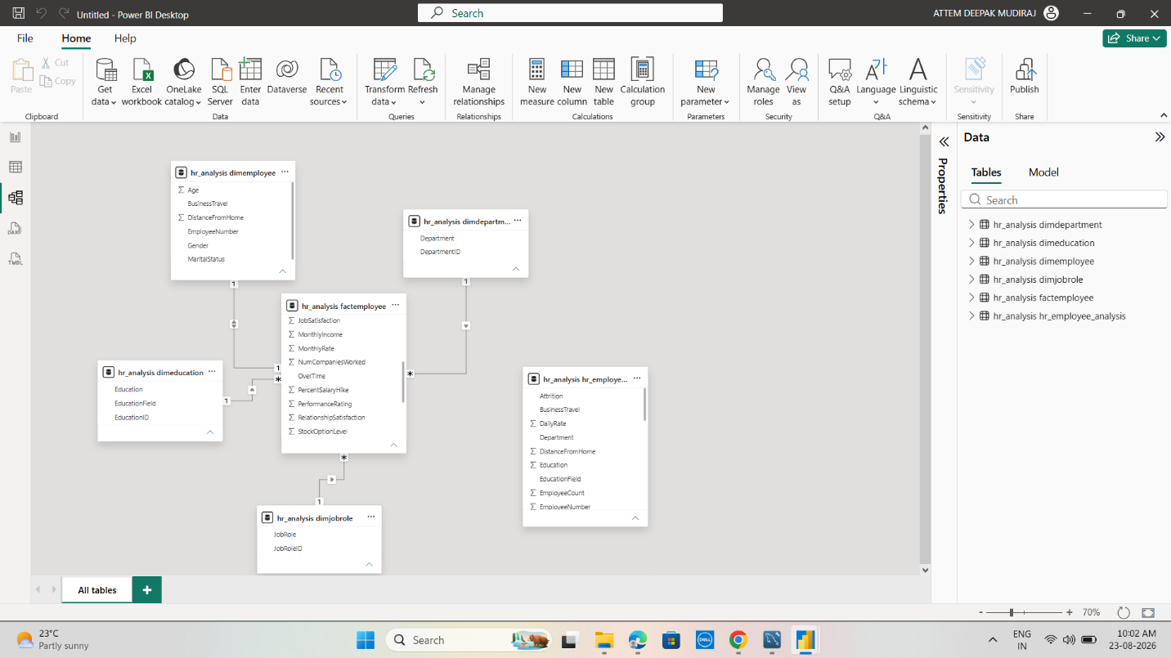
Using DAX to create New Measures:
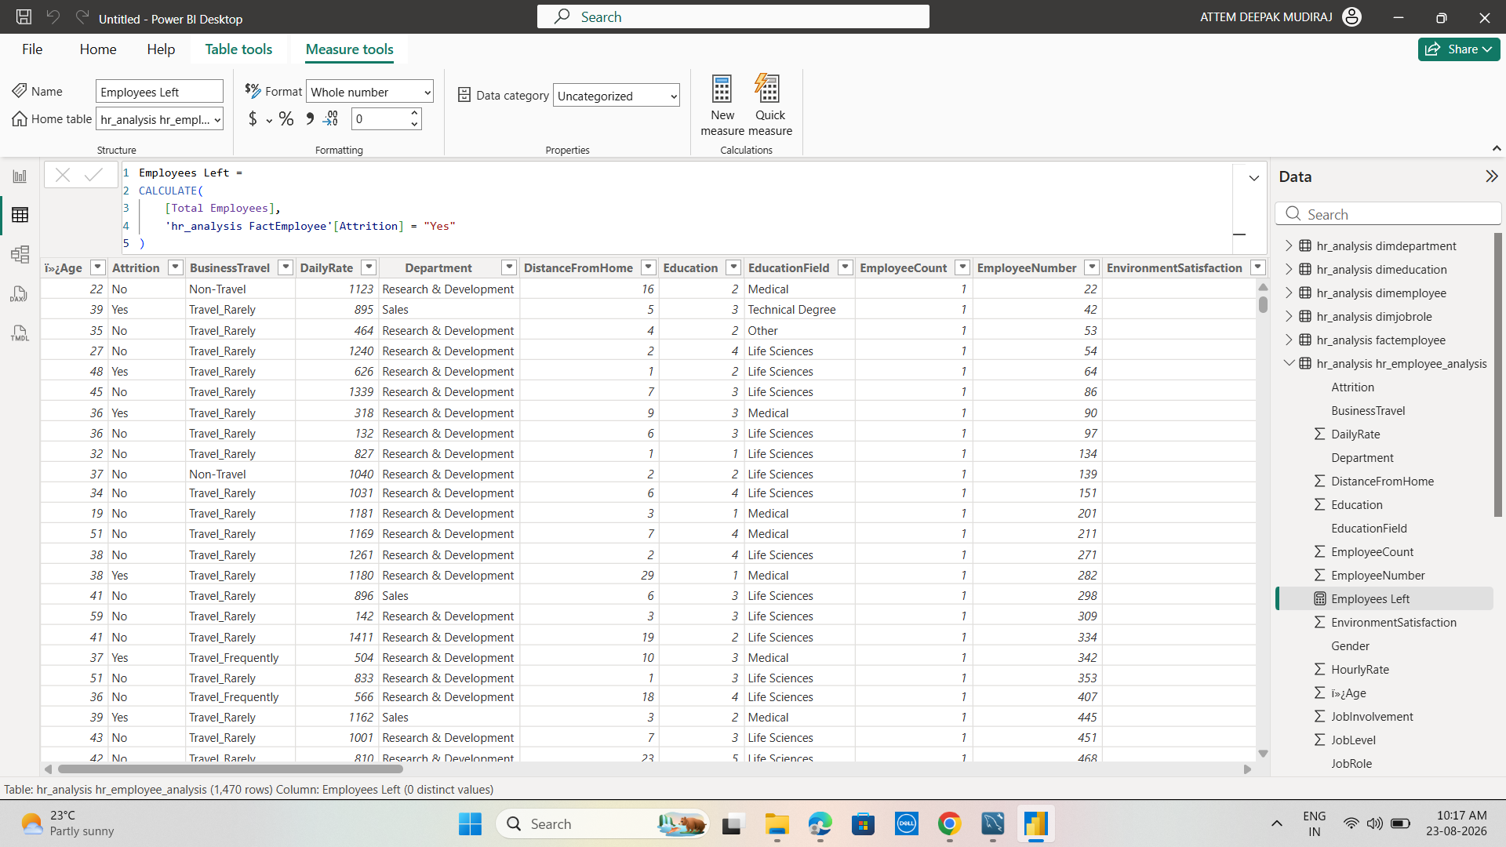

Dashboard:
Page 1:
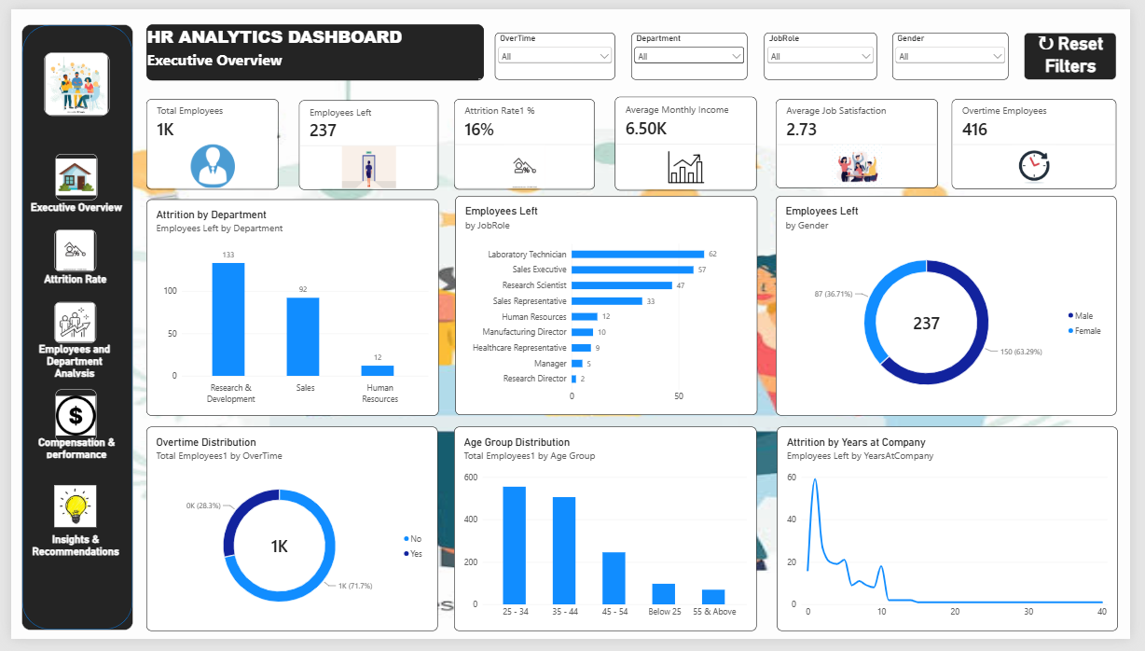
Page 2:
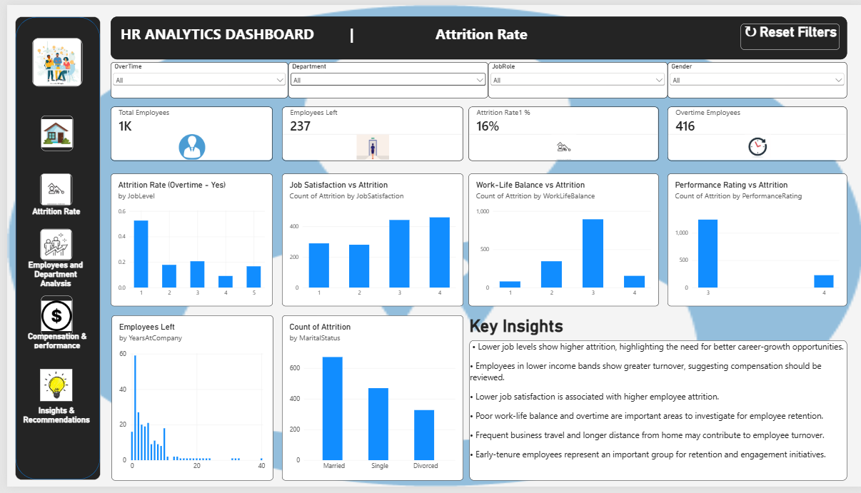

Connecting Power BI service:
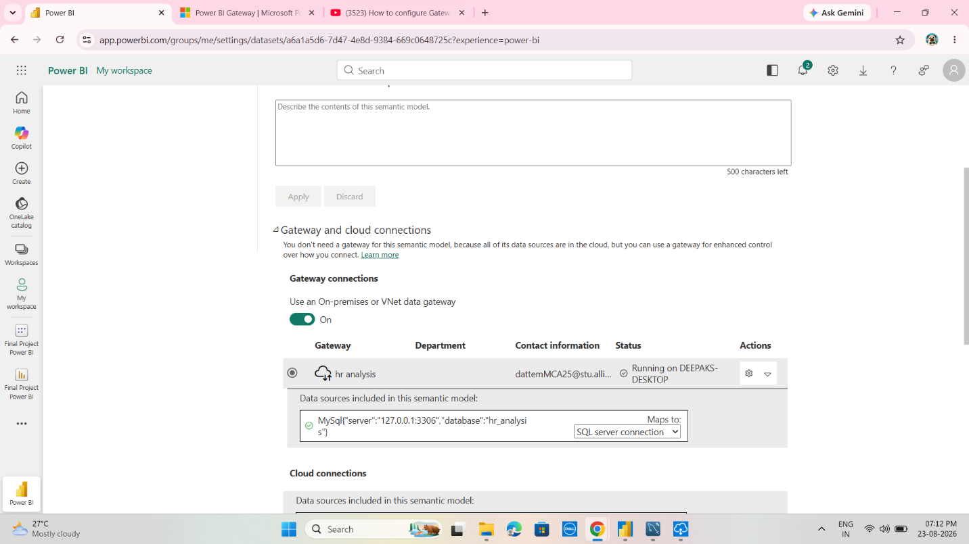
The Final Power BI Dashboard Provides:
- Interactive HR KPIs such as total employees, employees who left, attrition rate, average income, and overtime employees.
- Attrition analysis by department, job role, gender, job level, and age group.
- Employee satisfaction analysis based on job satisfaction and work-life balance.
- Compensation analysis using monthly income and income bands.
- Performance analysis based on performance ratings and salary hikes.
- Workforce behavior analysis covering overtime, business travel, distance from home, and tenure.
- Interactive filters and slicers for dynamic exploration of employee data.
- Reset Filters functionality for quickly returning the dashboard to its default view.
- Business insights and recommendations to support employee retention and HR decision-making.
- Power BI Service deployment with MySQL connectivity through an on-premises data gateway.

Conclusion
The HR Analytics project successfully developed an end-to-end Business Intelligence solution by integrating MySQL with Power BI. The project transformed raw HR data into a structured star-schema data model, performed data cleaning and transformation using Power Query, and created meaningful DAX-based KPIs and interactive dashboards.
The analysis provided insights into employee attrition, job satisfaction, compensation, overtime, work-life balance, performance, and workforce characteristics. These insights can help HR managers identify potential retention risks and make more informed workforce decisions.
Overall, the project demonstrates the complete journey from raw data → SQL database → data modeling → Power BI analysis → visualization → business insights, providing a practical and data-driven approach to HR decision-making.

Learning Outcomes
- Gained practical experience in end-to-end Business Intelligence and Analytics.
- Learned to connect and manage MySQL databases with Power BI.
- Developed skills in SQL queries and data preparation.
- Learned Power Query for data cleaning and transformation.
- Gained understanding of Fact and Dimension tables and Star Schema modeling.
- Developed DAX measures and KPI calculations for business analysis.
- Improved skills in designing interactive Power BI dashboards with slicers, filters, and bookmarks.
- Learned to analyze HR data and identify employee attrition and workforce trends.
- Developed the ability to convert analytical findings into business insights and actionable recommendations.
- Gained experience in Power BI Service deployment and data gateway connectivity.
- Improved overall understanding of how data-driven analytics supports business decision-making.

GitHub Repository: https://github.com/deepakMudiraj06/Power-BI/tree/main

GitHub Repository Folder: https://github.com/deepakMudiraj06/Power-BI/tree/main/Final%20Project

